Module Name: Database Systems
Student Name: Oluwaseun Adeyemi
Student ID: 77495238

Have a brief introduction of what the system is about and what is it that you’ll evidence in this section?

IMPLEMENTATION AND TESTING

1.2 INTRODUCTION
CARS4U is a rental company that consists of subsystems that make up the entire booking process to manage customers, both individual and corporate system. The overall system, which includes modules for managing vehicles, transactions, invoices, and contracting firms, was initially designed in Assessment 1. ERD for the system can be seen in figure 1.
This second assignment focuses on the design and implementation of the vehicle management system, a subsystem of the CARS4U database system. The subsystem contains four tables:
CLASS: stores details of the different type of vehicle classes owned by CARS4U and the associated daily rate charged.
FLEET: records fleets hired and the specific pool each fleet belongs to.
VEHICLE: captures details of vehicles owned by CARS4U.
ACCESSORY: This table stores data on accessories hired alongside the vehicles.
A supplementary table called MAKE_ MODEL table is also created although not part of the original ERD created in assignment 1. This table serves the purpose of storing vehicle makes and models in a separate reference table to help eliminate redundancy by ensuring that common make-model combinations are entered once and reused consistently across the system.

1.2 Implementation Screenshots
This section includes screenshots that show the implementation of the vehicle management subsystem in Oracle Apex, including table structures, constraints and views.
TABLE 1: CLASS TABLE: The class table consists of the following columns:
CLASS_ID: The class ID is the unique identifier for the class table. The numerical values for this column are automatically generated using sequence
CLASS_TYPE: This column holds VARCHAR values of the classes owned by CARS4U. Values for this table are inserted manually using SQL’s INSERT statement keyword.
CLASS_DAILY_RATE: The daily rate for each class is stored numerically in this column. The values are inserted using SQL’s INSERT statement.
Screenshots to show the columns, datatype and data can be seen in figure 1 and figure 2.

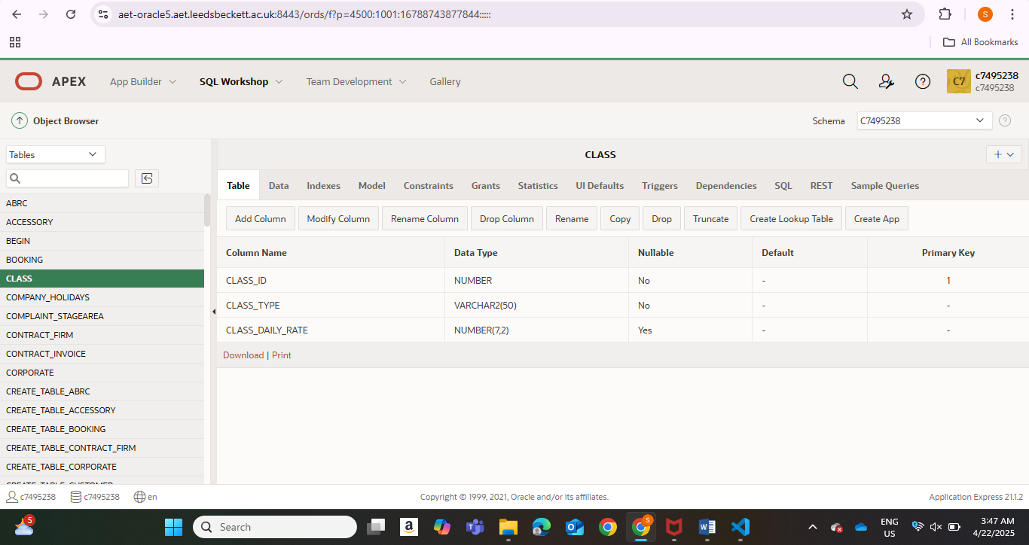
Figure 1
CLASS TABLE DATA
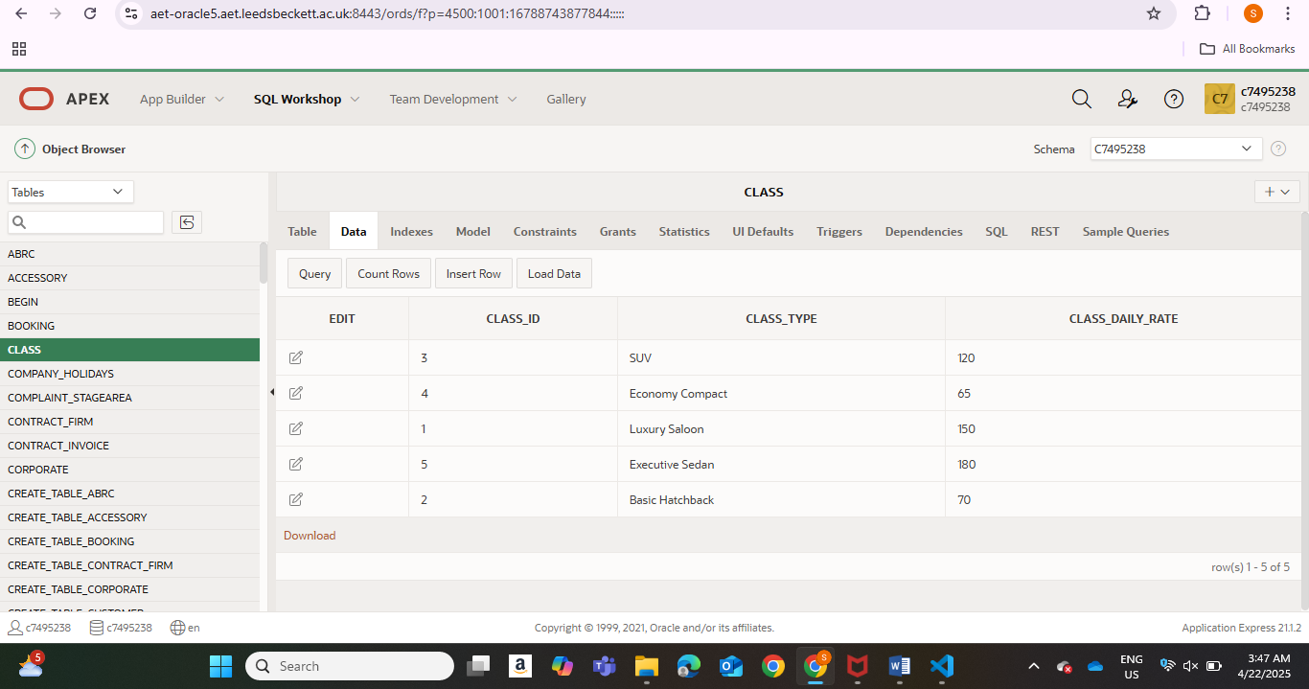
Figure 2
CLASS CONSTRAINT TABLE: The CLASS table constraints can be seen in figure 3. There are two check constraints type, Primary and check. The primary constraint ensures each record in the class table is uniquely identified. It ensures that the class_id column contains only unique and non-null values thus maintaining data integrity. A NOT NULL constraint was not explicitly stated for the class_id column as it is already a characteristic of primary key values to not allow for null values
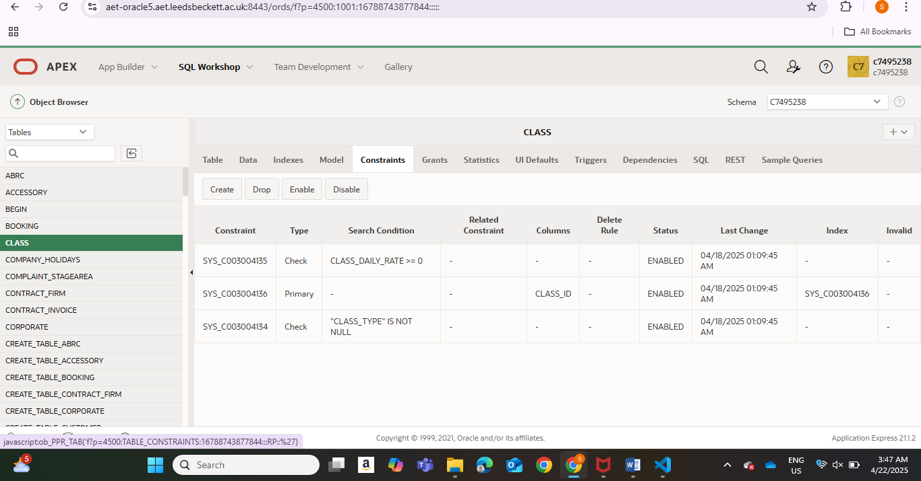
Figure 3

TABLE 2: FLEET TABLE
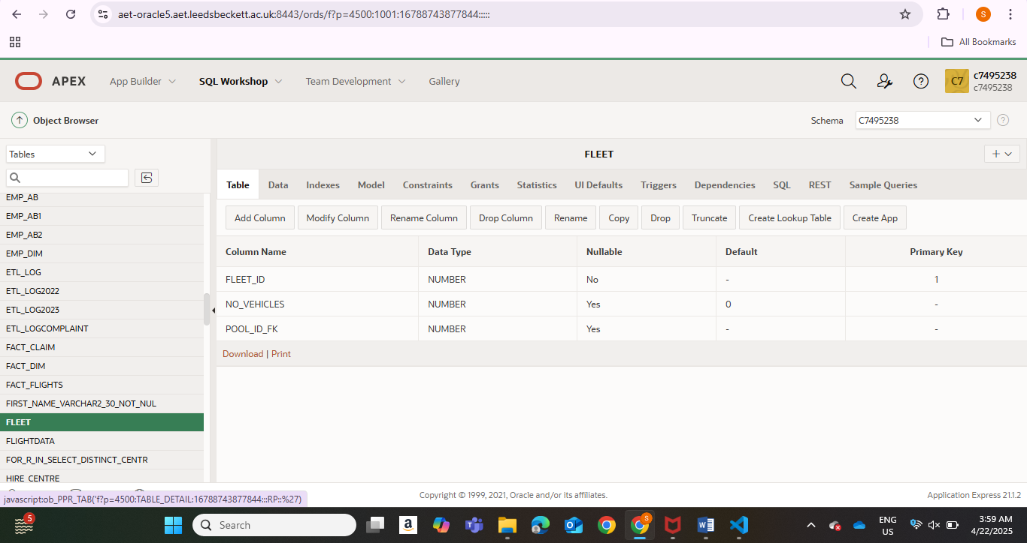
Figure 4
FLEET TABLE DATA
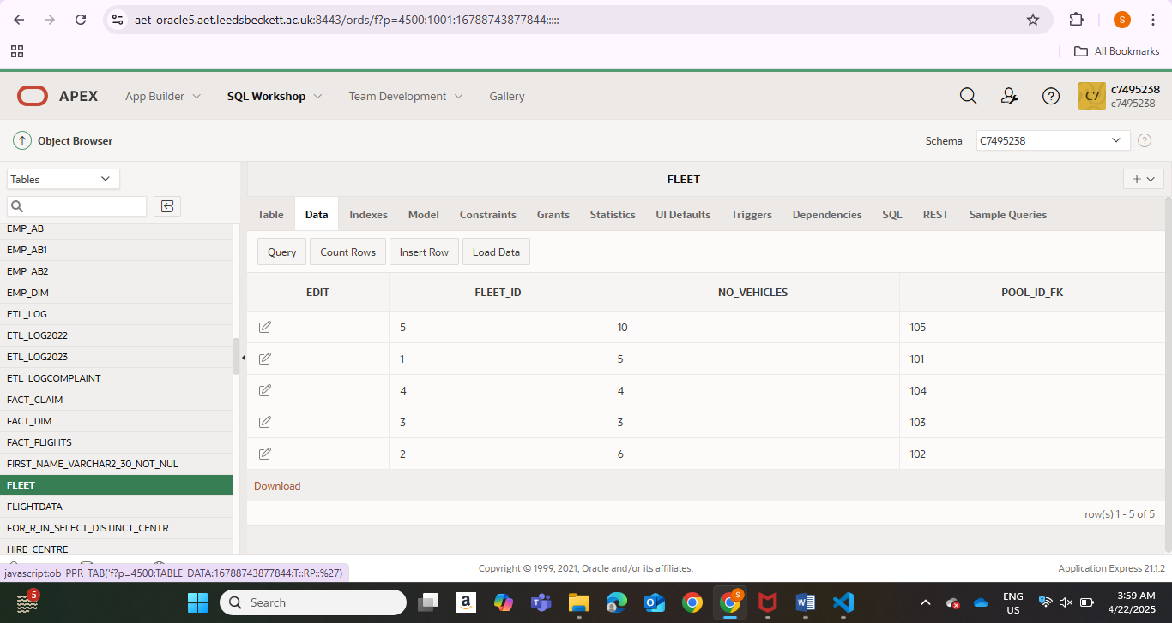
Figure 5

FLEET CONSTRAINT TABLE
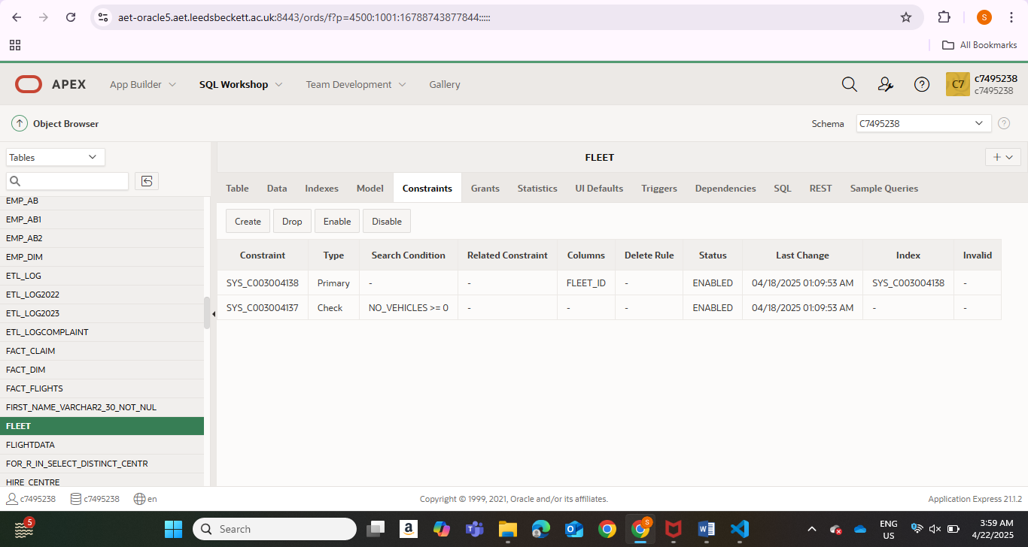
Figure 6

TABLE 3: VEHICLE TABLE
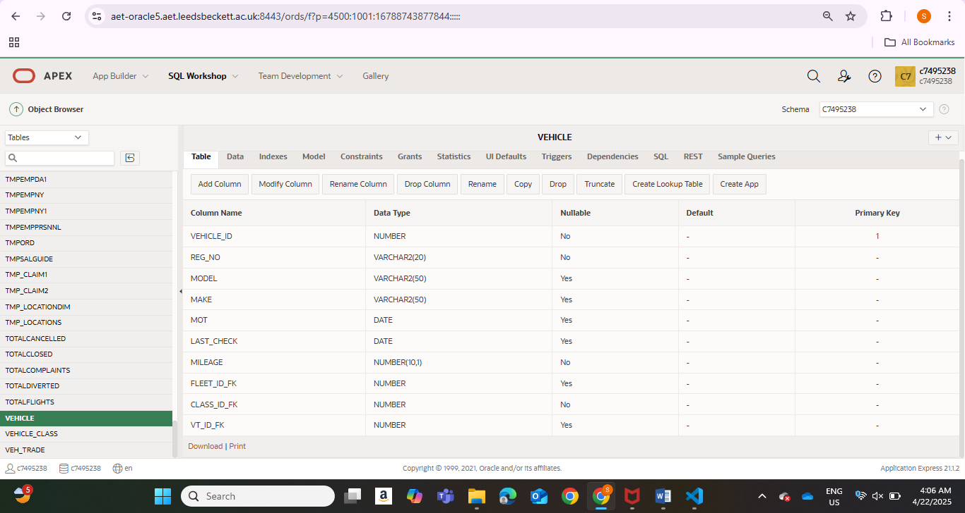
Figure 7

VEHICLE TABLE DATA
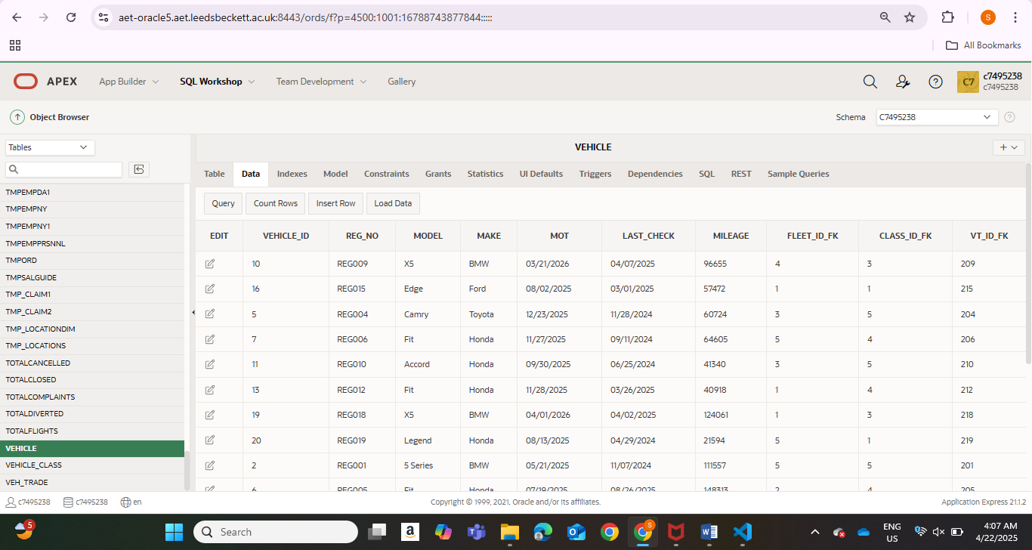
Figure 8
VEHICLE TABLE CONSTRAINT
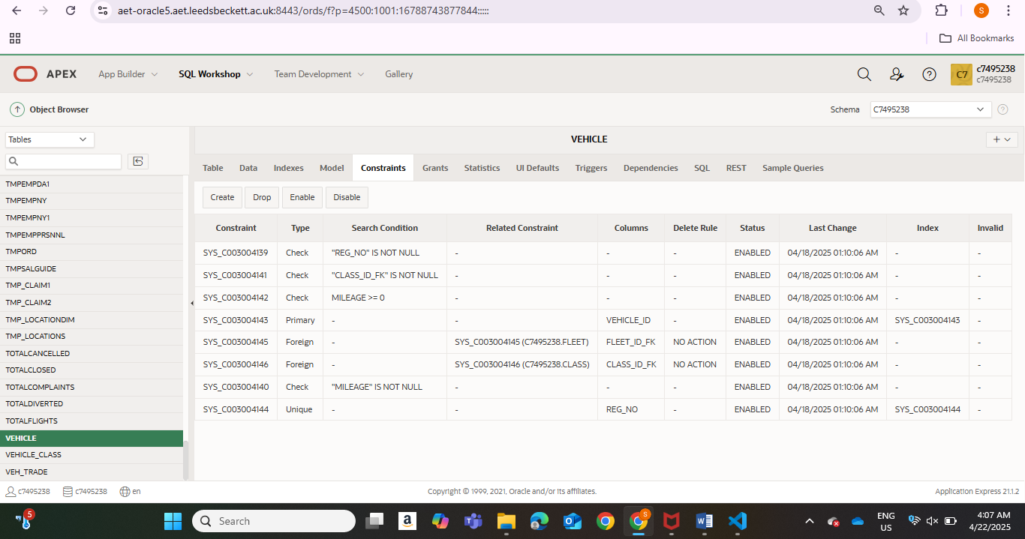
Figure 9

TABLE 4: ACCESSORY TABLE
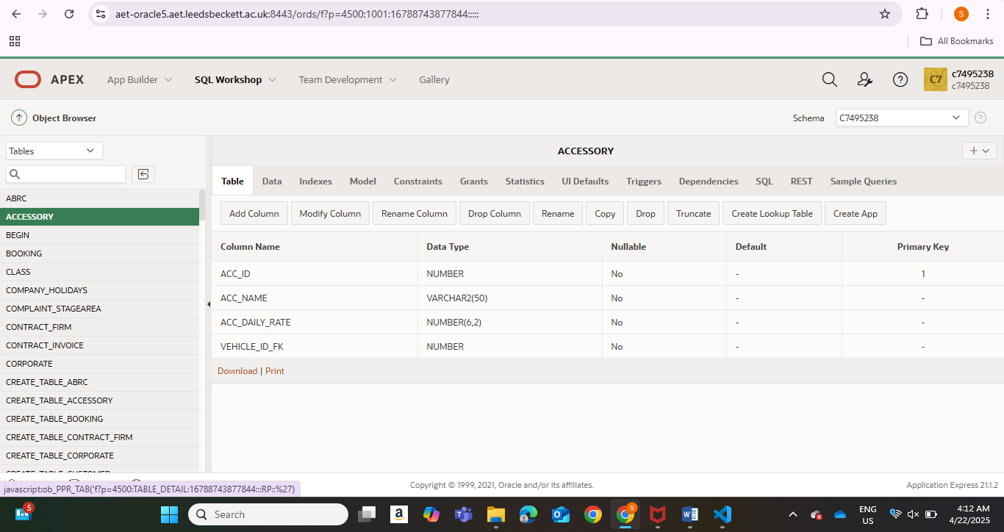
Figure 10
ACCESSORY TABLE DATA
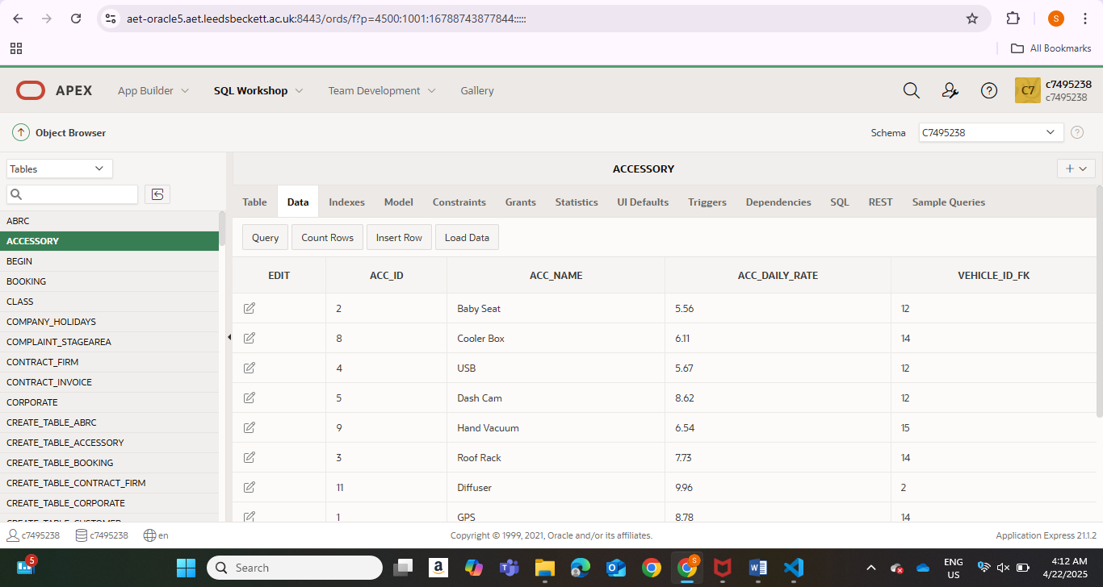
Figure 11

ACCESSORY TABLE CONSTRAINT
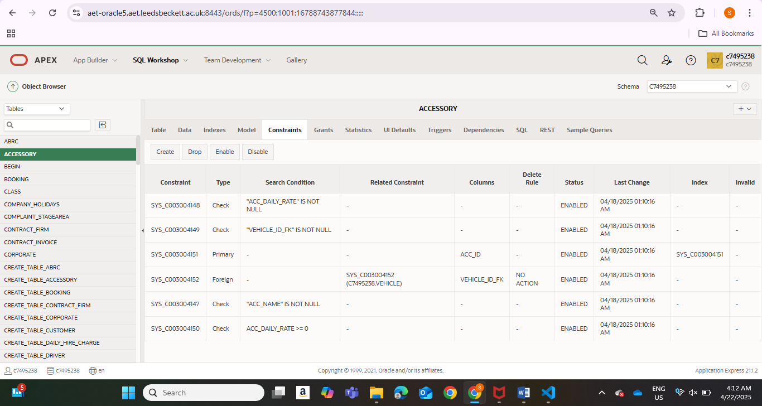
Figure 12

VIEWS
The vehicle subsystem contains two views, the vehicle_overview and fleet_summary views.
VEHICLE OVERVIEW
This view was created to simplify access to essential information about each vehicle by combining data from multiple related tables. It joins the VEHICLE, CLASS, FLEET, and ACCESSORY tables to provide a comprehensive snapshot of a vehicle’s registration details, classification type and rate, assigned fleet, and any accessories linked to it.
By using this view, users can easily generate reports or display vehicle details in the APEX application without writing complex SQL joins repeatedly. It enhances usability and supports better data analysis by consolidating relevant vehicle-related information into a single, queryable structure.

VEHICLE OVERVIEW TABLE
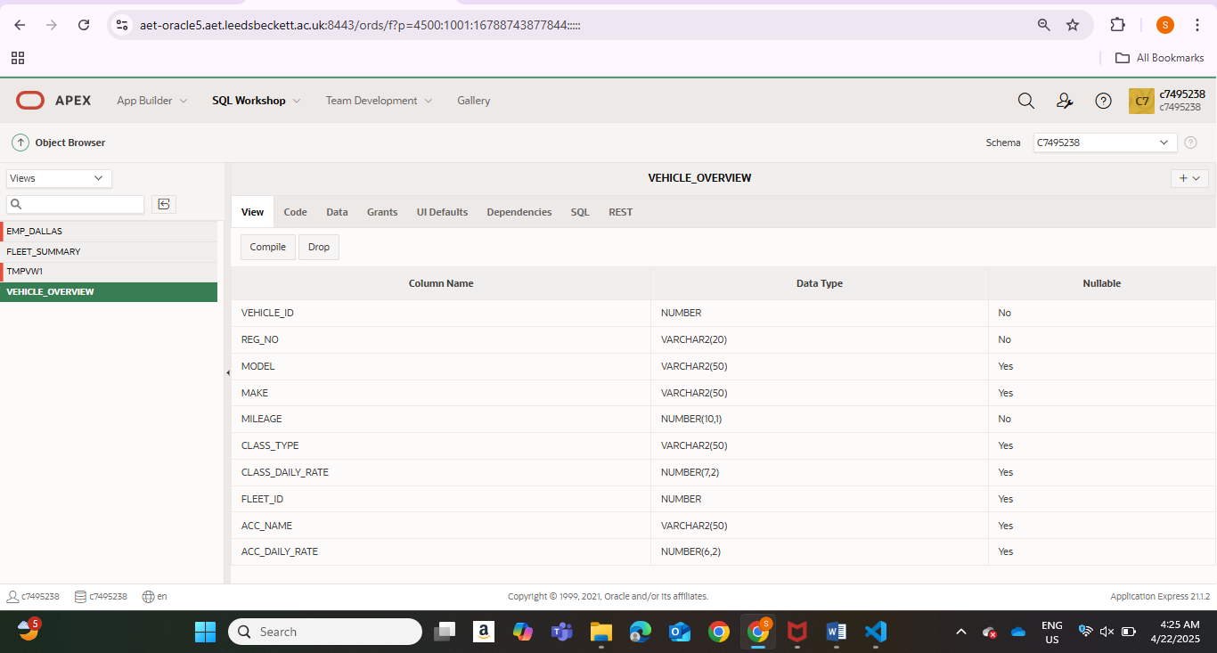
Figure 13
DATA ON THE VEHICLE OVERVIEW TABLE
Figure 14

FLEET SUMMARY
The FLEET_SUMMARY view was created to give a quick summary of how vehicles are distributed across different fleets. It displays each fleet’s ID, the total number of vehicles assigned to it, and the average mileage of those vehicles.
This view is particularly useful for fleet management and maintenance planning. It allows managers to monitor vehicle usage levels, identify underused or overused fleets, and make informed decisions about redistribution, servicing schedules, or vehicle replacement. It simplifies reporting by providing aggregated insights without needing to perform manual grouping and calculations.
FLEET SUMMARY TABLE
Figure 15
DATA ON THE FLEET TABLE
Figure 16

Discuss what is your focus of the solution and how is this useful for the business case study?
You can do this seun, fighting!!

